**LAPORAN PRAKTIKUM**

**BAHASA PEMROGRAMAN 1**

(**DOSEN PENGAMPU : DEDE HUSEN., M.KOM)**

**Modul 3**



DISUSUN OLEH :

NAMA : MOHAMAD ABAN SY’BANA

NIM : 20230810012

KELAS : TINFC-2023-04

**TEKNIK INFORMATIKA**

**FAKULTAS ILMU KOMPUTER**

**UNIVERSITAS KUNINGAN**

**2024**

**PreTest**

1. Apa itu Swing?

Jawab :

* Swing adalah pustaka GUI (Graphical User Interface) di Java yang menyediakan berbagai komponen untuk membuat antarmuka pengguna. Swing merupakan bagian dari Java Foundation Classes (JFC) dan sering digunakan untuk mengembangkan aplikasi desktop. Swing menyediakan komponen-komponen seperti tombol, label, panel, menu, tabel, dan lain-lain yang bisa digunakan untuk membuat aplikasi dengan antarmuka grafis.

1. Apa fungsi dari Swing?

Jawab :

* Membuat aplikasi desktop dengan berbagai elemen GUI.
* Mengontrol tampilan dan perilaku komponen GUI.
* Membuat antarmuka pengguna yang platform-independent (dapat berjalan di berbagai sistem operasi tanpa perubahan kode).

1. Tuliskan contoh program sederhana untuk Swing container dan menu!

Jawab :

import javax.swing.*;

public class SwingExample {

public static void main(String[] args) {

// Membuat frame

JFrame frame = new JFrame("Contoh Program Swing");

frame.setDefaultCloseOperation(JFrame.EXIT_ON_CLOSE);

frame.setSize(400, 300);

// Membuat menu bar

JMenuBar menuBar = new JMenuBar();

// Membuat menu

JMenu menuFile = new JMenu("File");

JMenu menuEdit = new JMenu("Edit");

// Membuat item menu

JMenuItem menuItemNew = new JMenuItem("New");

JMenuItem menuItemOpen = new JMenuItem("Open");

JMenuItem menuItemExit = new JMenuItem("Exit");

// Menambahkan item ke dalam menu "File"

menuFile.add(menuItemNew);

menuFile.add(menuItemOpen);

menuFile.addSeparator(); // Menambahkan separator

menuFile.add(menuItemExit);

// Menambahkan menu ke dalam menu bar

menuBar.add(menuFile);

menuBar.add(menuEdit);

// Menambahkan menu bar ke frame

frame.setJMenuBar(menuBar);

// Menampilkan frame

frame.setVisible(true);

}

}

**Praktikum 1**

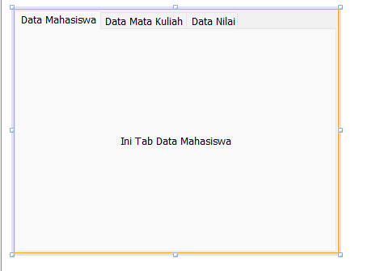

**Praktikum 2**

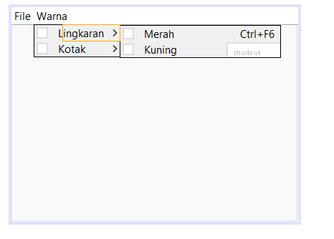

**Posttes**

1. Buat java class baru dengan nama BP1_M3_POSTTES1_Aban

* Buat from menu data nilai mahasiswa (file,data mahasiswa,data MK, data nilai)
* Pada menu masing-masing memiliki 2 menu item yang jika di klik menampilkan data sesuai dengan nama menu item

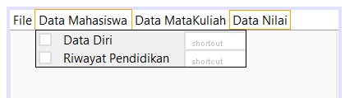

**Tugas**

Lengkapi form menu pada postes sehingga menjadi rancangan program form data nilai mahasiswa yang interaktif.

* Disini saya memodifikasi data mahasiswa menjadi sebuah button Dimana saat di klik menu data mahasiswa akan menuju ke data diri dan Riwayat Pendidikan seperti gambar di bawah ini :

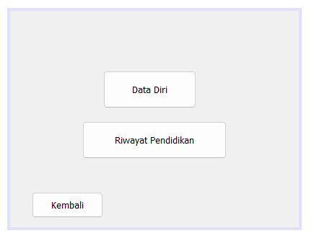

* Ketika di klik button data diri tersebut otomatis akan menuju ke gambar di bawah ini

Code ini sudah termasuk data diri, riwayat pendidikan dan kembali

/*

* To change this license header, choose License Headers in Project Properties.

* To change this template file, choose Tools | Templates

* and open the template in the editor.

*/

/**

*

* @author Suci Indah Lestari

*/

public class Data_dm extends javax.swing.JFrame {

/**

* Creates new form Data_dm

*/

public Data_dm() {

initComponents();

}

/**

* This method is called from within the constructor to initialize the form.

* WARNING: Do NOT modify this code. The content of this method is always

* regenerated by the Form Editor.

*/

@SuppressWarnings("unchecked")

// <editor-fold defaultstate="collapsed" desc="Generated Code">

private void initComponents() {

jButton1 = new javax.swing.JButton();

jButton2 = new javax.swing.JButton();

jButton3 = new javax.swing.JButton();

setDefaultCloseOperation(javax.swing.WindowConstants.EXIT_ON_CLOSE);

jButton1.setText("Data Diri");

jButton1.addMouseListener(new java.awt.event.MouseAdapter() {

public void mouseClicked(java.awt.event.MouseEvent evt) {

jButton1MouseClicked(evt);

}

});

jButton2.setText("Riwayat Pendidikan");

jButton2.addMouseListener(new java.awt.event.MouseAdapter() {

public void mouseClicked(java.awt.event.MouseEvent evt) {

jButton2MouseClicked(evt);

}

});

jButton3.setText("Kembali");

jButton3.addMouseListener(new java.awt.event.MouseAdapter() {

public void mouseClicked(java.awt.event.MouseEvent evt) {

jButton3MouseClicked(evt);

}

});

javax.swing.GroupLayout layout = new javax.swing.GroupLayout(getContentPane());

getContentPane().setLayout(layout);

layout.setHorizontalGroup(

layout.createParallelGroup(javax.swing.GroupLayout.Alignment.LEADING)

.addGroup(layout.createSequentialGroup()

.addGap(129, 129, 129)

.addComponent(jButton1, javax.swing.GroupLayout.PREFERRED_SIZE, 129, javax.swing.GroupLayout.PREFERRED_SIZE)

.addContainerGap(142, Short.MAX_VALUE))

.addGroup(javax.swing.GroupLayout.Alignment.TRAILING, layout.createSequentialGroup()

.addContainerGap(javax.swing.GroupLayout.DEFAULT_SIZE, Short.MAX_VALUE)

.addComponent(jButton2, javax.swing.GroupLayout.PREFERRED_SIZE, 200, javax.swing.GroupLayout.PREFERRED_SIZE)

.addContainerGap(javax.swing.GroupLayout.DEFAULT_SIZE, Short.MAX_VALUE))

.addGroup(layout.createSequentialGroup()

.addGap(30, 30, 30)

.addComponent(jButton3, javax.swing.GroupLayout.PREFERRED_SIZE, 99, javax.swing.GroupLayout.PREFERRED_SIZE)

.addContainerGap(javax.swing.GroupLayout.DEFAULT_SIZE, Short.MAX_VALUE))

);

layout.setVerticalGroup(

layout.createParallelGroup(javax.swing.GroupLayout.Alignment.LEADING)

.addGroup(layout.createSequentialGroup()

.addGap(83, 83, 83)

.addComponent(jButton1, javax.swing.GroupLayout.PREFERRED_SIZE, 52, javax.swing.GroupLayout.PREFERRED_SIZE)

.addGap(18, 18, 18)

.addComponent(jButton2, javax.swing.GroupLayout.PREFERRED_SIZE, 52, javax.swing.GroupLayout.PREFERRED_SIZE)

.addPreferredGap(javax.swing.LayoutStyle.ComponentPlacement.RELATED, 46, Short.MAX_VALUE)

.addComponent(jButton3, javax.swing.GroupLayout.PREFERRED_SIZE, 36, javax.swing.GroupLayout.PREFERRED_SIZE)

.addContainerGap())

);

pack();

}// </editor-fold>

private void jButton1MouseClicked(java.awt.event.MouseEvent evt) {

// TODO add your handling code here:

dataDiri_dm dd = new dataDiri_dm();

dd.setVisible(true);

}

private void jButton2MouseClicked(java.awt.event.MouseEvent evt) {

// TODO add your handling code here:

rp_dm rp = new rp_dm();

rp.setVisible(true);

}

private void jButton3MouseClicked(java.awt.event.MouseEvent evt) {

// TODO add your handling code here:

BP1_POSTES_M3_Aban kembali = new BP1_POSTES_M3_Aban();

kembali.setVisible(true);

}

/**

* @param args the command line arguments

*/

public static void main(String args[]) {

/* Set the Nimbus look and feel */

//<editor-fold defaultstate="collapsed" desc=" Look and feel setting code (optional) ">

/* If Nimbus (introduced in Java SE 6) is not available, stay with the default look and feel.

* For details see http://download.oracle.com/javase/tutorial/uiswing/lookandfeel/plaf.html

*/

try {

for (javax.swing.UIManager.LookAndFeelInfo info : javax.swing.UIManager.getInstalledLookAndFeels()) {

if ("Nimbus".equals(info.getName())) {

javax.swing.UIManager.setLookAndFeel(info.getClassName());

break;

}

}

} catch (ClassNotFoundException ex) {

java.util.logging.Logger.getLogger(Data_dm.class.getName()).log(java.util.logging.Level.SEVERE, null, ex);

} catch (InstantiationException ex) {

java.util.logging.Logger.getLogger(Data_dm.class.getName()).log(java.util.logging.Level.SEVERE, null, ex);

} catch (IllegalAccessException ex) {

java.util.logging.Logger.getLogger(Data_dm.class.getName()).log(java.util.logging.Level.SEVERE, null, ex);

} catch (javax.swing.UnsupportedLookAndFeelException ex) {

java.util.logging.Logger.getLogger(Data_dm.class.getName()).log(java.util.logging.Level.SEVERE, null, ex);

}

//</editor-fold>

/* Create and display the form */

java.awt.EventQueue.invokeLater(new Runnable() {

public void run() {

new Data_dm().setVisible(true);

}

});

}

// Variables declaration - do not modify

private javax.swing.JButton jButton1;

private javax.swing.JButton jButton2;

private javax.swing.JButton jButton3;

// End of variables declaration

}

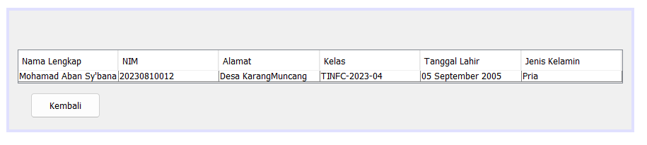

* Sama halnya dengan button data diri, Ketika di klik button Riwayat Pendidikan otomatis akan menuju ke gambar di bawah ini

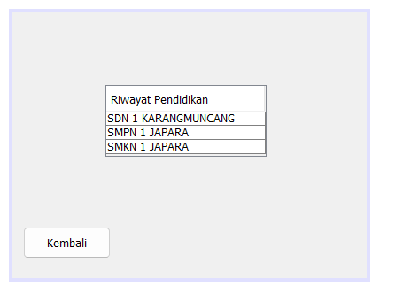

* Disini saya memodifikasi data mata kuliah menjadi sebuah button Dimana saat di klik menu data mata kuliah akan menuju ke nama dosen dan mata kuliah seperti gambar di bawah ini :

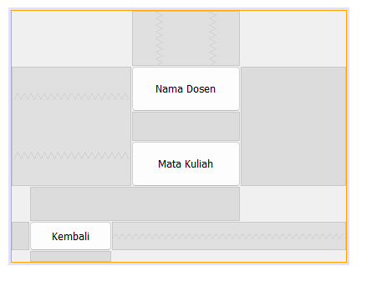

* Ya mungkin sama hal nya dengan penjelasan seperti data diri dan Riwayat Pendidikan

Code di bawah ini sudah termasuk nama dosen mata kuliah dan kembali

/*

* To change this license header, choose License Headers in Project Properties.

* To change this template file, choose Tools | Templates

* and open the template in the editor.

*/

/**

*

* @author Suci Indah Lestari

*/

public class ND_MK extends javax.swing.JFrame {

/**

* Creates new form ND_MK

*/

public ND_MK() {

initComponents();

}

/**

* This method is called from within the constructor to initialize the form.

* WARNING: Do NOT modify this code. The content of this method is always

* regenerated by the Form Editor.

*/

@SuppressWarnings("unchecked")

// <editor-fold defaultstate="collapsed" desc="Generated Code">

private void initComponents() {

jButton1 = new javax.swing.JButton();

jButton2 = new javax.swing.JButton();

jButton3 = new javax.swing.JButton();

setDefaultCloseOperation(javax.swing.WindowConstants.EXIT_ON_CLOSE);

jButton1.setText("Mata Kuliah");

jButton1.addMouseListener(new java.awt.event.MouseAdapter() {

public void mouseClicked(java.awt.event.MouseEvent evt) {

jButton1MouseClicked(evt);

}

});

jButton2.setText("Nama Dosen");

jButton2.addMouseListener(new java.awt.event.MouseAdapter() {

public void mouseClicked(java.awt.event.MouseEvent evt) {

jButton2MouseClicked(evt);

}

});

jButton3.setText("Kembali");

jButton3.addMouseListener(new java.awt.event.MouseAdapter() {

public void mouseClicked(java.awt.event.MouseEvent evt) {

jButton3MouseClicked(evt);

}

});

javax.swing.GroupLayout layout = new javax.swing.GroupLayout(getContentPane());

getContentPane().setLayout(layout);

layout.setHorizontalGroup(

layout.createParallelGroup(javax.swing.GroupLayout.Alignment.LEADING)

.addGroup(javax.swing.GroupLayout.Alignment.TRAILING, layout.createSequentialGroup()

.addContainerGap(143, Short.MAX_VALUE)

.addGroup(layout.createParallelGroup(javax.swing.GroupLayout.Alignment.TRAILING)

.addComponent(jButton2, javax.swing.GroupLayout.PREFERRED_SIZE, 131, javax.swing.GroupLayout.PREFERRED_SIZE)

.addComponent(jButton1, javax.swing.GroupLayout.PREFERRED_SIZE, 131, javax.swing.GroupLayout.PREFERRED_SIZE))

.addGap(126, 126, 126))

.addGroup(layout.createSequentialGroup()

.addGap(21, 21, 21)

.addComponent(jButton3, javax.swing.GroupLayout.PREFERRED_SIZE, 99, javax.swing.GroupLayout.PREFERRED_SIZE)

.addContainerGap(javax.swing.GroupLayout.DEFAULT_SIZE, Short.MAX_VALUE))

);

layout.setVerticalGroup(

layout.createParallelGroup(javax.swing.GroupLayout.Alignment.LEADING)

.addGroup(javax.swing.GroupLayout.Alignment.TRAILING, layout.createSequentialGroup()

.addContainerGap(66, Short.MAX_VALUE)

.addComponent(jButton2, javax.swing.GroupLayout.PREFERRED_SIZE, 55, javax.swing.GroupLayout.PREFERRED_SIZE)

.addGap(35, 35, 35)

.addComponent(jButton1, javax.swing.GroupLayout.PREFERRED_SIZE, 55, javax.swing.GroupLayout.PREFERRED_SIZE)

.addGap(41, 41, 41)

.addComponent(jButton3, javax.swing.GroupLayout.PREFERRED_SIZE, 36, javax.swing.GroupLayout.PREFERRED_SIZE)

.addContainerGap())

);

pack();

}// </editor-fold>

private void jButton2MouseClicked(java.awt.event.MouseEvent evt) {

// TODO add your handling code here:

ND_table mkt = new ND_table();

mkt.setVisible(true);

}

private void jButton1MouseClicked(java.awt.event.MouseEvent evt) {

// TODO add your handling code here:

MK_ND mkd = new MK_ND();

mkd.setVisible(true);

}

private void jButton3MouseClicked(java.awt.event.MouseEvent evt) {

// TODO add your handling code here:

BP1_POSTES_M3_Aban kembali = new BP1_POSTES_M3_Aban();

kembali.setVisible(true);

}

/**

* @param args the command line arguments

*/

public static void main(String args[]) {

/* Set the Nimbus look and feel */

//<editor-fold defaultstate="collapsed" desc=" Look and feel setting code (optional) ">

/* If Nimbus (introduced in Java SE 6) is not available, stay with the default look and feel.

* For details see http://download.oracle.com/javase/tutorial/uiswing/lookandfeel/plaf.html

*/

try {

for (javax.swing.UIManager.LookAndFeelInfo info : javax.swing.UIManager.getInstalledLookAndFeels()) {

if ("Nimbus".equals(info.getName())) {

javax.swing.UIManager.setLookAndFeel(info.getClassName());

break;

}

}

} catch (ClassNotFoundException ex) {

java.util.logging.Logger.getLogger(ND_MK.class.getName()).log(java.util.logging.Level.SEVERE, null, ex);

} catch (InstantiationException ex) {

java.util.logging.Logger.getLogger(ND_MK.class.getName()).log(java.util.logging.Level.SEVERE, null, ex);

} catch (IllegalAccessException ex) {

java.util.logging.Logger.getLogger(ND_MK.class.getName()).log(java.util.logging.Level.SEVERE, null, ex);

} catch (javax.swing.UnsupportedLookAndFeelException ex) {

java.util.logging.Logger.getLogger(ND_MK.class.getName()).log(java.util.logging.Level.SEVERE, null, ex);

}

//</editor-fold>

/* Create and display the form */

java.awt.EventQueue.invokeLater(new Runnable() {

public void run() {

new ND_MK().setVisible(true);

}

});

}

// Variables declaration - do not modify

private javax.swing.JButton jButton1;

private javax.swing.JButton jButton2;

private javax.swing.JButton jButton3;

// End of variables declaration

}

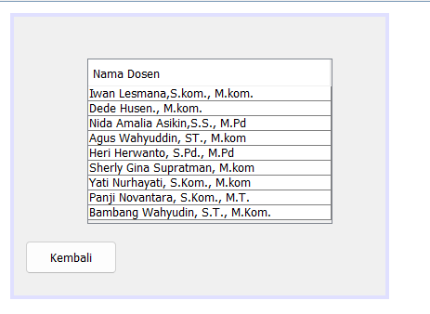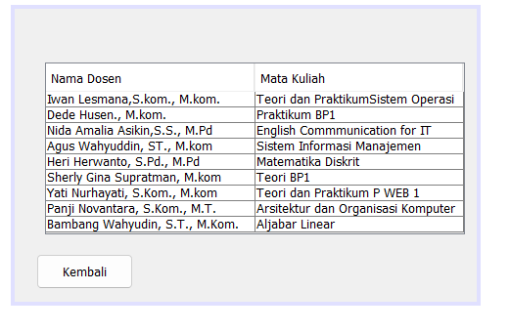

* Disini saya memodifikasi data nilai menjadi sebuah button Dimana saat di klik menu data nilai akan menuju ke nilai uts dan uas seperti gambar di bawah ini :

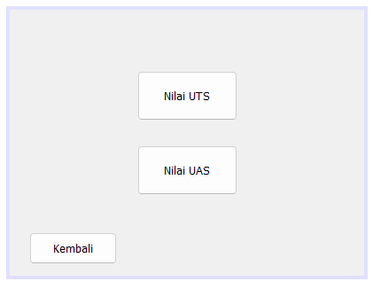

* Penjelasan masih sama dengan data diri dan Riwayat Pendidikan

Code ini sudah termasuk nilai uts, nilai uas dan Kembali

/*

* To change this license header, choose License Headers in Project Properties.

* To change this template file, choose Tools | Templates

* and open the template in the editor.

*/

/**

*

* @author Suci Indah Lestari

*/

public class DN extends javax.swing.JFrame {

/**

* Creates new form DN

*/

public DN() {

initComponents();

}

/**

* This method is called from within the constructor to initialize the form.

* WARNING: Do NOT modify this code. The content of this method is always

* regenerated by the Form Editor.

*/

@SuppressWarnings("unchecked")

// <editor-fold defaultstate="collapsed" desc="Generated Code">

private void initComponents() {

jButton1 = new javax.swing.JButton();

jButton2 = new javax.swing.JButton();

jButton3 = new javax.swing.JButton();

setDefaultCloseOperation(javax.swing.WindowConstants.EXIT_ON_CLOSE);

jButton1.setText("Nilai UTS");

jButton1.addMouseListener(new java.awt.event.MouseAdapter() {

public void mouseClicked(java.awt.event.MouseEvent evt) {

jButton1MouseClicked(evt);

}

});

jButton2.setText("Nilai UAS");

jButton2.addMouseListener(new java.awt.event.MouseAdapter() {

public void mouseClicked(java.awt.event.MouseEvent evt) {

jButton2MouseClicked(evt);

}

});

jButton3.setText("Kembali");

jButton3.addMouseListener(new java.awt.event.MouseAdapter() {

public void mouseClicked(java.awt.event.MouseEvent evt) {

jButton3MouseClicked(evt);

}

});

javax.swing.GroupLayout layout = new javax.swing.GroupLayout(getContentPane());

getContentPane().setLayout(layout);

layout.setHorizontalGroup(

layout.createParallelGroup(javax.swing.GroupLayout.Alignment.LEADING)

.addGroup(layout.createSequentialGroup()

.addGroup(layout.createParallelGroup(javax.swing.GroupLayout.Alignment.LEADING)

.addGroup(layout.createSequentialGroup()

.addGap(144, 144, 144)

.addGroup(layout.createParallelGroup(javax.swing.GroupLayout.Alignment.LEADING)

.addComponent(jButton2, javax.swing.GroupLayout.PREFERRED_SIZE, 113, javax.swing.GroupLayout.PREFERRED_SIZE)

.addComponent(jButton1, javax.swing.GroupLayout.PREFERRED_SIZE, 113, javax.swing.GroupLayout.PREFERRED_SIZE)))

.addGroup(layout.createSequentialGroup()

.addGap(22, 22, 22)

.addComponent(jButton3, javax.swing.GroupLayout.PREFERRED_SIZE, 99, javax.swing.GroupLayout.PREFERRED_SIZE)))

.addContainerGap(143, Short.MAX_VALUE))

);

layout.setVerticalGroup(

layout.createParallelGroup(javax.swing.GroupLayout.Alignment.LEADING)

.addGroup(layout.createSequentialGroup()

.addContainerGap(69, Short.MAX_VALUE)

.addComponent(jButton1, javax.swing.GroupLayout.PREFERRED_SIZE, 56, javax.swing.GroupLayout.PREFERRED_SIZE)

.addGap(28, 28, 28)

.addComponent(jButton2, javax.swing.GroupLayout.PREFERRED_SIZE, 56, javax.swing.GroupLayout.PREFERRED_SIZE)

.addGap(42, 42, 42)

.addComponent(jButton3, javax.swing.GroupLayout.PREFERRED_SIZE, 36, javax.swing.GroupLayout.PREFERRED_SIZE)

.addContainerGap())

);

pack();

}// </editor-fold>

private void jButton1MouseClicked(java.awt.event.MouseEvent evt) {

// TODO add your handling code here:

N_uts nuts = new N_uts();

nuts.setVisible(true);

}

private void jButton2MouseClicked(java.awt.event.MouseEvent evt) {

// TODO add your handling code here:

N_uas nuas = new N_uas();

nuas.setVisible(true);

}

private void jButton3MouseClicked(java.awt.event.MouseEvent evt) {

// TODO add your handling code here:

BP1_POSTES_M3_Aban kembali = new BP1_POSTES_M3_Aban();

kembali.setVisible(true);

}

/**

* @param args the command line arguments

*/

public static void main(String args[]) {

/* Set the Nimbus look and feel */

//<editor-fold defaultstate="collapsed" desc=" Look and feel setting code (optional) ">

/* If Nimbus (introduced in Java SE 6) is not available, stay with the default look and feel.

* For details see http://download.oracle.com/javase/tutorial/uiswing/lookandfeel/plaf.html

*/

try {

for (javax.swing.UIManager.LookAndFeelInfo info : javax.swing.UIManager.getInstalledLookAndFeels()) {

if ("Nimbus".equals(info.getName())) {

javax.swing.UIManager.setLookAndFeel(info.getClassName());

break;

}

}

} catch (ClassNotFoundException ex) {

java.util.logging.Logger.getLogger(DN.class.getName()).log(java.util.logging.Level.SEVERE, null, ex);

} catch (InstantiationException ex) {

java.util.logging.Logger.getLogger(DN.class.getName()).log(java.util.logging.Level.SEVERE, null, ex);

} catch (IllegalAccessException ex) {

java.util.logging.Logger.getLogger(DN.class.getName()).log(java.util.logging.Level.SEVERE, null, ex);

} catch (javax.swing.UnsupportedLookAndFeelException ex) {

java.util.logging.Logger.getLogger(DN.class.getName()).log(java.util.logging.Level.SEVERE, null, ex);

}

//</editor-fold>

/* Create and display the form */

java.awt.EventQueue.invokeLater(new Runnable() {

public void run() {

new DN().setVisible(true);

}

});

}

// Variables declaration - do not modify

private javax.swing.JButton jButton1;

private javax.swing.JButton jButton2;

private javax.swing.JButton jButton3;

// End of variables declaration

}

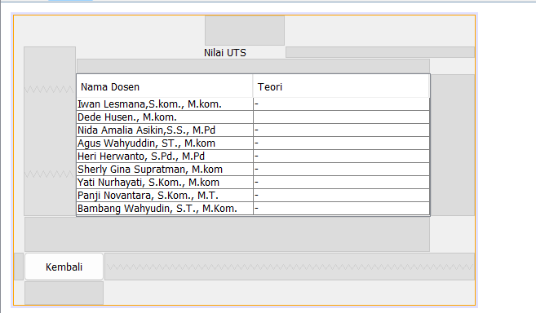

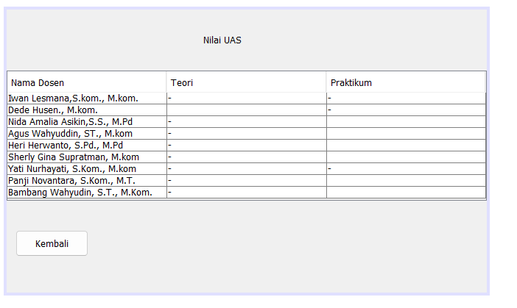

Catatan :

Untuk membuat table seperti di atas kalian ke swing menus lalu cari nama table kemudian drag ke jFrame nya untuk mengatur nya kalian klik kanan lalu ke bagian columns atur count nya sesuai kalian mau kalua ingin hapus kalian kilk title yg mana saja lalu delete nah setelah it uke bagian rows klik masing masing bagian bawah title isi dengan kemauan kalian sendiri lalu setelah diisi kalian close klik yg bagian pojok kanan bawah. Untuk code Kembali kalian ketikan seperti kata di bawah ini

namaFile variabel = new namaFile();

variabel.setVisible(true);

Metode setVisible(true) biasanya digunakan untuk menampilkan jendela atau frame menjadikan komponen tersebut terlihat di layar.